Building an Android HTTP Server on Windows using ServerCore.cpp in the XMLFoundation

Download and install the latest Android NDK ([developer.android.com/tools/sdk/ndk/index.html](http://developer.android.com/tools/sdk/ndk/index.html) )

Do not put a space in the path name that you unzip the NDK into.

Download and install the latest Android SDK (<http://developer.android.com/sdk/index.html> )

Download and install the latest JDK (Java Development Kit) <http://www.oracle.com/technetwork/java/javase/downloads/index.html>

Download XMLFoundation ( <https://skydrive.live.com/redir?resid=D7EC275E76D295CF!585> )

As shown in the following image,

Add the JAVA_HOME to where you have the JDK installed. Note: on 2/1/2014 the default jdk folder was “C:\Program Files\Java\jdk1.7.0_51”

Add the NDK_PROJECT_PATH environment variable to where ever you have the [\XMLFoundation\Examples\Android\Server] folder from XMLFoundation

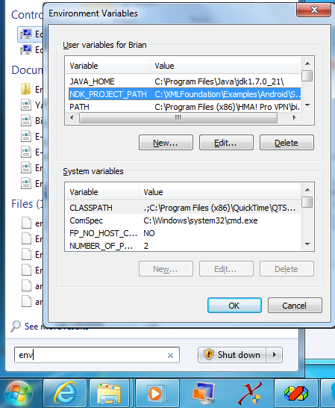

Start a new cmd shell. Note that once the env has been changed only a NEW shell will have the current env settings.

Start/Accessories/Command Prompt

Or “WindowKey-R” then type cmd. WindowKey is next to “Alt” and “R” is short for Run.

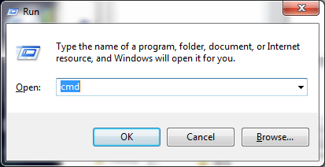

In the cmd shell, type “ndk-build” from the folder you unzipped the AndroidNDK into

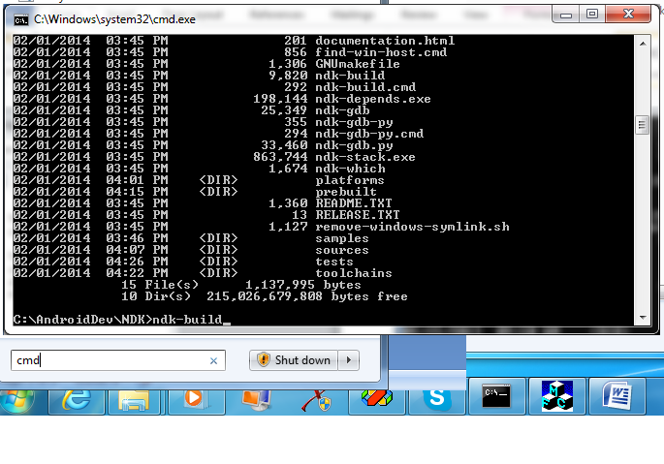

You will see this:

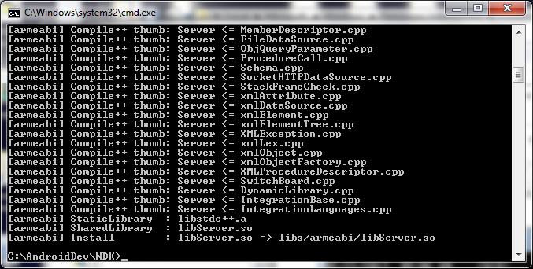

Start Eclipse - the development IDE in the Android SDK



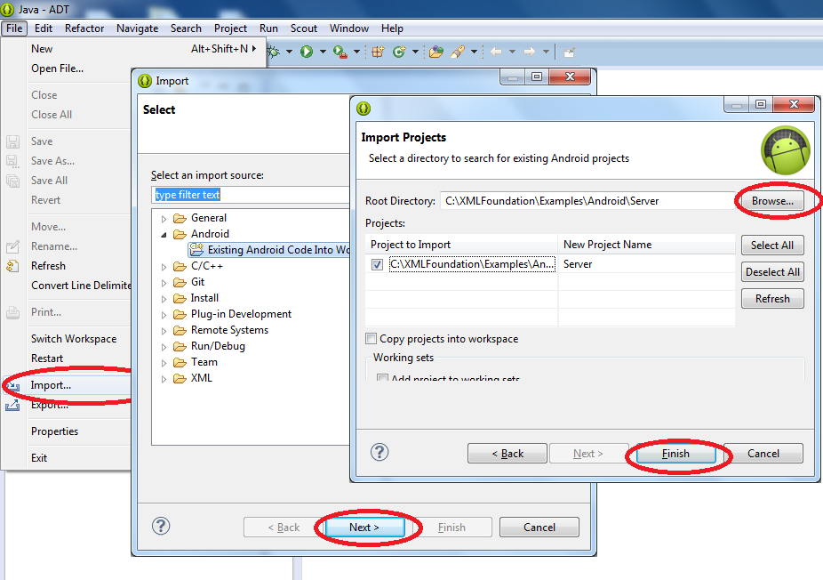

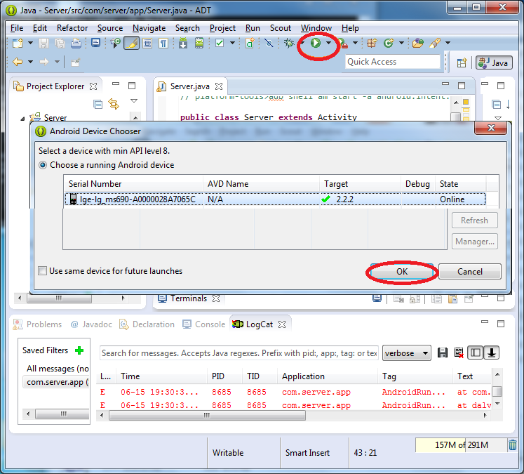

A picture is worth a thousand words.

It will run the HTTP server on your phone/tablet.

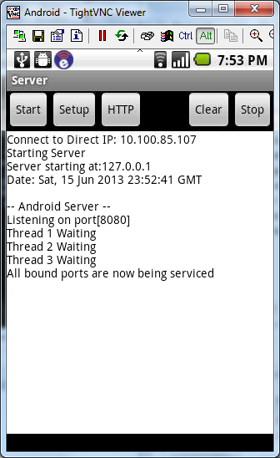

That’s it. I hope this provides you a helpful starting point for your own project that now has a multithreaded TCP Server core and all the XMLFoundation tools available to you on Android.